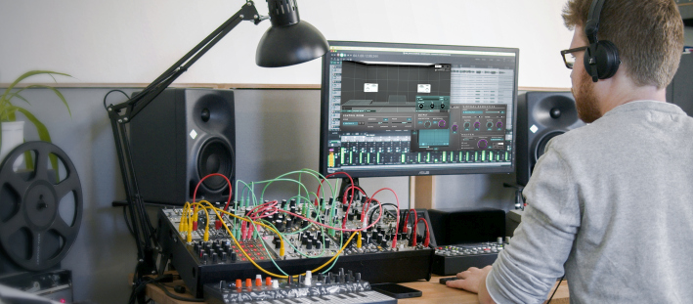

Dear Reality launches Stereo Production Bundle
Brand-new plugin bundle combines dearVR MIX with the dearVR MUSIC spatializer

Düsseldorf, 22 March 2022 – Immersive audio specialist Dear Reality are launching a plugin bundle to enhance any stereo production with a simplified mixing workflow and uniquely spatial audio. The STEREO PRODUCTION BUNDLE includes the dearVR MIX virtual mix room plug-in and the dearVR MUSIC spatializer plug-in. While dearVR MIX ensures reliable headphone mixing in customizable virtual mix rooms, dearVR MUSIC adds a 360° panner and spatial reverb that gives depth and width to a mix.

“By combining our high-precision dearVR MIX virtual mix room with the advanced dearVR MUSIC spatializer, we are ensuring fully reliable stereo mixing through headphones while at the same time breaking down the barriers of stereo to add unique depth and width to a recording,” explains Achim Fell, co-CEO of Dear Reality.

dearVR MUSIC – adding spatiality to stereo mixes
The dearVR MUSIC plugin turns any DAW into a 3D audio powerhouse. This spatializer plugin has been designed to break down the limitations of crowded stereo mixes. It relies on 18 true-to-life virtual acoustic environments for music production, such as a concert hall, church, stage, drum room, and many more. “With dearVR MUSIC’s advanced virtual acoustics, you can enrich every production with an immersive feel for the listener,” says Christian Sander, co-CEO of Dear Reality. “The plug-in provides a big sound to all instruments that you want to sound huge.”
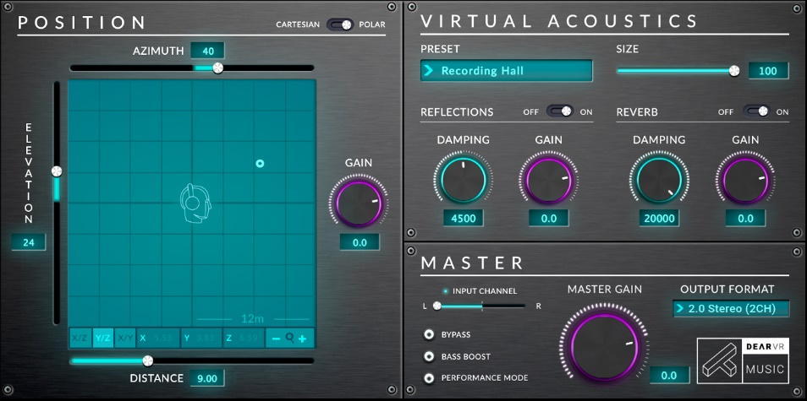 | dearVR MUSIC provides a big and wide sound to any instrument

dearVR MIX
With dearVR MIX, engineers and content producers can count on what they hear and be sure that their mixes will translate well to other sound systems and locations, whether they are on the road or in the studio. Based on advanced spatial audio technology, dearVR MIX turns any studio headphones into a world-class stereo mix room with carefully designed acoustics. The plug-in also features Dear Reality’s Spatial Headphone Compensation. This adapts the 45 most used professional studio headphones to the selected virtual mixing room, enabling a model-independent, stable simulation of a perfect acoustic environment.

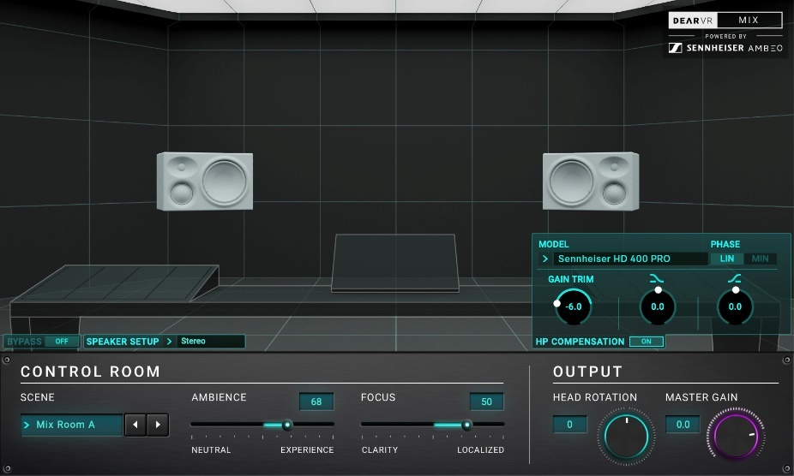 | dearVR MIX provides outstanding acoustics and ensures maximum reliability for headphone monitoring

The Stereo Production Bundle is available in the Dear Reality store now, priced at EUR 169 (plus local VAT) or USD 189 (plus local VAT).

(Ends)

The images accompanying this press release can be downloaded here.
Please visit the Dear Reality Blog.

About Dear Reality
Dear Reality is a leading company in the field of immersive audio controllers, best known for its binaural, Ambisonics, and multichannel encoders with totally realistic room virtualization. The company’s products are used worldwide by sound engineers, sound designers, broadcasters, and musicians. Founded in 2014 by Achim Fell and Christian Sander, Dear Reality strives to deliver high-quality, cutting-edge 3D audio software for interactive and linear audio production. Since 2019, Dear Reality has been proud to be a part of the Sennheiser Group.

Global Press Contact

Kai Detlefsen
press@dear-reality.com

